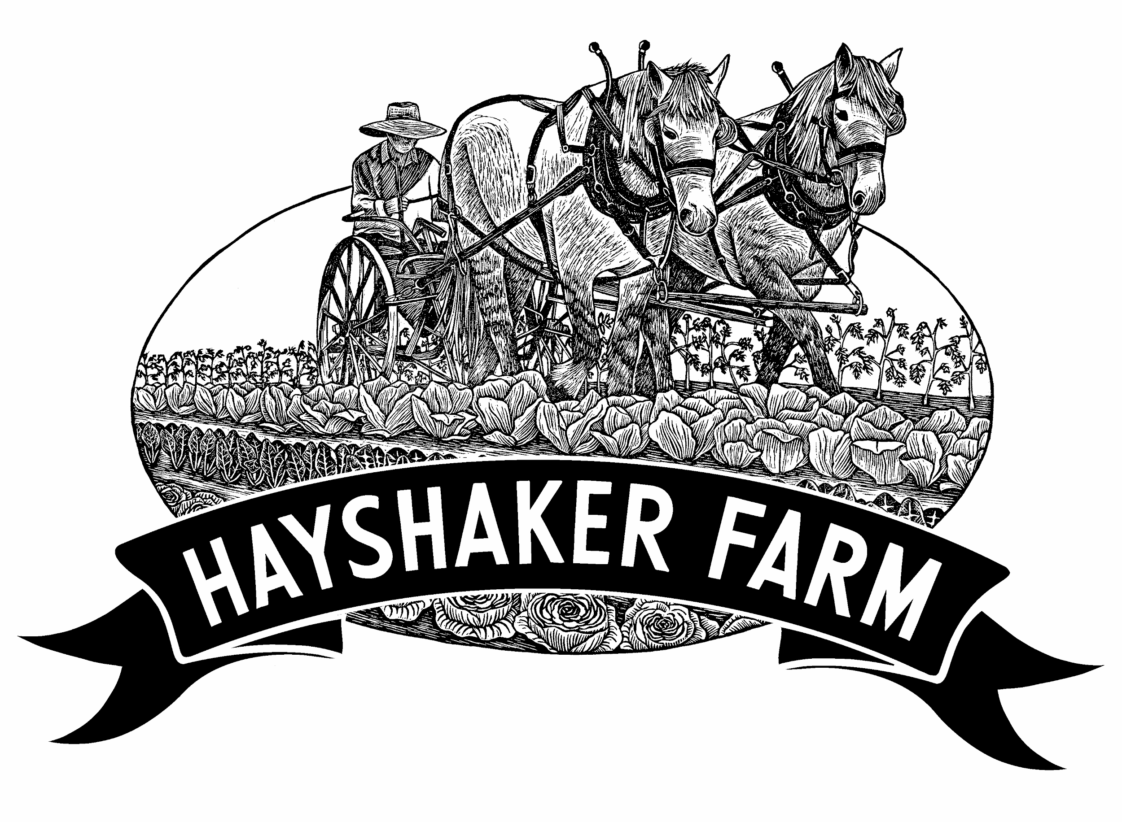

Posted: November 2023
Starts: flexible, November - December 2023

Time commitment: December - March average 15-25 hrs/week
April - November average 30-40 hrs/week
Occasional overtime (40+hrs/week), paid at time+half

Schedule: Monday - Friday, starting between 6-9am
(ex: 6am in summer, 9am in winter), occasional weekend chores
Compensation: $18-20/hr, DOE
$10/month phone stipend

Paid sick leave: 1 hour earned for every 40 hours worked

Vacations: 80 hours paid/year, 40 hours earned every 6 months
More unpaid time off possible with pre-approval

We are looking for smart, strong and detail-oriented folks to join our farm crew. The Food Hub Co-Manager position is designed to be an immersive and dynamic full time job, involving product coordination & inventory management, pulling & packing orders, computer & office work, teamwork & coworker management, cleaning and organizing, delivery & customer interaction, sales and marketing. Find a rough breakdown on duties below. Walla Walla Food Hub is located at Hayshaker Farm and is part of the same business–time worked is one paycheck, one W-2. All ideal farm crew candidates will have a strong interest in food and farming, and enjoy working both on a team and individually. Join our small but mighty crew growing food and feeding the community. Produce and food hub goods are sold to local, regional and state-wide families, restaurants, groceries, and food banks. Applications are reviewed as they are received.
Responsibilities
- Direct duties (~70-80%)
  - Product coordination & Inventory Management, Pulling & Packing orders: keep produce and food hub products organized, clean & properly labeled, and listed in our online marketplace
  - Computer & Office Work: Gmail, Google voice, Google Drive products, Slack, spreadsheets, online food hub software (Local Food Marketplace & Routific)
  - Teamwork & Coworker Management: Directly manage coworkers in assisting food hub work, communicate with all coworkers on Slack
  - Communicate with our harvest manager to list what’s available for sale and about incoming produce; coordinate listing
  - Cleaning and organizing: Maintain clean work areas and manage stock of bags, boxes & packing materials
  - Delivery & customer interaction: Deliver produce to town, drive a large refrigerated truck in town and on highways; possible cross-state deliveries
  - Sales & Marketing: Help communicate with wholesale accounts on our Google Voice number, including conducting sales, managing order changes, discussing product availability, coordinating deliveries & pickups
- Farm work (~20-30%) - flexible if not desired, please mention in your application
  - Assist in harvest and wash/pack, and in bulk harvest & wash days
  - Assist in field work including but not limited to seeding, transplanting, trellising, hand weeding, hoeing, using row cover, and moving irrigation
  - Assist in some of the following work: greenhouse work, plant starts, tractor driving, farm clean up, farm projects and construction, winter high tunnel snow removal, winter chores & feeding

Background, Skills & Expectations
- Practical knowledge of local farms, ability to understand the needs of different groceries for proper packing and storage is desired
- Experience working in farming, grocery or food hubs is desired
- Flexibility and desire to learn new methods and farm systems
- Attention to detail, with emphasis on quality control
- Self-starter mentality, always looking for how to help the team
- Good communication skills
- Energetic and motivated personality
- Excellent work ethic and positive attitude, adaptability to challenges
- Conscientious and able to work with all kinds of people
- Strong back and knees
- Ability to work outside in all weather conditions: hot summers, cold winters
- Willingness to commit to the farm for the full year, ideally two
- Ability to drive large van required; ability to drive stick shift helpful but not required

More details…

What you can expect from us:
- 17 years of farming experience in ownership, and nearly 44 years experience in the whole current crew
- Approaching relationships with care, love, curiosity and compassion
- Investment in tools, equipment and improvements
- Flexibility for time off
- Focus on work/life balance, through communication and time spent
- Understanding that no one is perfect
- Desire to feed all community members, regardless of income level
- Some farm mottos we have posted around the place: “Have fun and be safe,” “Every Farm Needs a Team,” and “Eat the Rainbow”

Housing: we can help search for a private apartment or house if you’re moving from out of town, and ask our network about rentals. There is no housing available on the farm. All employees from out of town have found housing.

Food: all farm seconds and some items we grow are available for the crew. Wholesale cost on other products sold in our food hub. Meals are on your own, with some weekly shared lunches.

Professional Development: up to $300/year budget for pre-approved conferences/workshops + travel

Paid Worker’s Compensation: covered with LNI state program
Paid Family Medical Leave: new program in WA state began 2020

To Apply: Complete the Food Hub Co-Manager Application for Employment below. Submit along with your resume.
Food Hub Co-Manager Application for Employment
329 SW 12th Street, College Place, WA 99324 - info@hayshakerfarm.com

Please send this application fully completed to the above web or mail address. Incomplete applications will not be accepted.

Today’s Date:_______________________ Pronouns: _______________________

Full Name:______________________________________________________________

Address:________________________________________________________________

Phone Number(s):_________________________________________________________

Email:__________________________________________________________

Are you 18 years of age or older?____________________

Are you eligible to work in the United States?_____________________

1. Where did you hear about employment opportunities at Hayshaker Farm/WW Food Hub?

2. Why do you want to work at Hayshaker Farm and the Walla Walla Food Hub?

3. When could you start and how long are you looking for employment?

4. How many hours per week do you want to work? Are there any days of the week you don’t want to work?

5. Do you have any vacations or time off planned?

6. What do you consider to be your biggest achievement so far?

7. What education, formal or informal, have you completed?

8. Do you have experience doing repetitive tasks for long periods of time?

9. How about working outside in extreme weather conditions (ie. Rain, snow, high winds, etc.)? Working in wet conditions under cover in cold weather?

10. Describe any customer service experience you have. Do you enjoy customer service?

11. What do you think will be the most challenging aspect of working at Hayshaker/Walla Walla Food Hub?

12. Do you have any health conditions, recurring injuries, recent accidents, etc. that would
prevent you from doing strenuous physical labor? Please list all of them below.

a) Can you repeatedly lift 50 lbs?

b) Can you repeatedly bend over and stand up, without getting dizzy or straining yourself?

c) Can you kneel for long periods of time?

d) Can you stand in one place for long periods of time?

13. Do you have reliable transportation (bike, car, scooter…) and a current driver’s license?

14. What makes you unique?

15. What is your five year plan?

16. Please provide the following information for your three most recent employers:
Business Name:
Supervisor’s Name:
City, ST:
Phone:
Begin & End Dates:
Job Title:
Why Left:

Business Name:
Supervisor’s Name:
City, ST:
Phone:
Begin & End Dates:
Job Title:
Why Left:

Business Name:
Supervisor’s Name:
City, ST:
Phone:
Begin & End Dates:
Job Title:
Why Left:

17. Please list contact info for three professional references: (can be two of your previous employers)

18. Please include additional information (skills, aptitudes, interests, hobbies etc.) that would be
useful to know as we consider your potential employment.

I attest that the information I have provided above is complete and true to the best of my knowledge.

______________________________________ _______________
Applicant’s Signature Date

Thank you for applying to work at Hayshaker Farm & Walla Walla Food Hub! We look forward to reading your application and speaking further - Hayshaker Hiring Team

